**The Dev’s Story: Video Game Developers of the Philippines**

(A Web Video Feature promoting PC Game Developers of the Philippines)

JUAN CARLOS SANTIAGO

June 2014

**BACKGROUND**

Video games have always been overlooked and underappreciated in the Philippines. Studies suggested that video games are a main contributor to intellectual sedation, it imposes violence, and it can develop addiction, depression, and aggression. But recent studies have surfaced claiming that there are positive benefits of video games.

A study suggests that video games benefit a person’s cognitive skills, emotional stability, social skills, and his/her motivation. As for the cognitive skills, this is true particularly to gamers who play *action* games. Scholars have speculated that videogames are an excellent means of developing problem-solving skills. With regards to emotional benefits, researchers say that, though it generates negative emotions such as frustration, gaming is the best way to elicit positive emotions for children and the youth because of the feeling of gratification as they get their reward in a puzzle game for example. Gamers who play online games exhibit prosocial behaviors like the encouragement of cooperativity in game play which lead them to be more sociable in game and outside of it. Games, specifically action first person shooters, are now being used for training when it comes to combat, with its real time strategy and teamwork, it trains new recruits for battle.

The Philippine gaming community is slowly growing, and the company Anino Games started it with their game released in 2001 called “Anito: Defend the Land Enraged”. A Game Developers Association of the Philippines recently just formed, and it groups the game developers of today in hopes of promoting the game developers that has recently surfaced. Right now, the group is booming as different game developers try to join in, adding to the game developing society of the Philippines.

There are recently published games that have significance in the society today. One of these is the game “Assassin’s Creed III” as, although it is based on the United States of America, it shows the rich history of the revolution. Another is the game “Bioshock:Infinite”, and this game allows the player to understand the possibilities of a multi-dimensional reality and there are possibilities of you making yourself a bad influence based only on your decisions.

**PROJECT DESCRIPTION**

The project is a web info that will feature Philippine game developers who already made PC games and their respective games developed.

**PROJECT RATIONALE**

The proponent believes that the video game developers of the Philippines can create a video game that can reach a quality as same as the leading game developing companies such as Ubisoft, Rockstar, etc. with reasonable funding. Funding is not an issue anymore as there is crowdsourcing.

The proponent also believes that video games have potential not just in giving relief and entertainment but, like books, can give the audience a wide range of imagination and can influence the well-being of a gamer.

**PROJECT OBJECTIVE**

The project aims to:

1. Present benefits derived from high quality video games;
2. Promote video game developers in the Philippines;
3. Persuade gamers to patronize the games made in the Philippines.

**COMMUNICATION OBJECTIVE**

PROJECT OBJECTIVE # 1: Present benefits derived from high quality video games.

1. Provide information about video games.
2. Show what gamers can get from video games.

PROJECT OBJECTIVE # 2: Promote video game developers in the Philippines.

1. Showcase game developers in the Philippines.
2. Show the life of a game developer

PROJECT OBJECTIVE # 3: Persuade gamers to patronize the games made in the Philippines.

1. Support the game development community in the Philippines
2. Influence young gamers in patronizing games made in the Philippines

**THEORETICAL FRAMEWORK**

**PROJECT BRIEF**

**Technical Description**

The project is about the current situation of PC video games and independent game developers of the Philippines. The website will contain a video featuring interviews of current game developers and their games. The website will also contain the biographies of the interviewed body and a page for the description of the companies. The website is suitable for all ages as it it will contain information about games that the youth will see.

The main video will show the hardships in making a game. It will start with the pre-production phase of making a game, then going to the production, then the distribution of the game. The video will also discuss the flukes of the first PC video game made by Anino Games and why it didn’t become popular. The main video will also contain interviews of asset creators and their involvement in making a game.

**Content Outline**

The website will contain 4 pages with different content as follows:

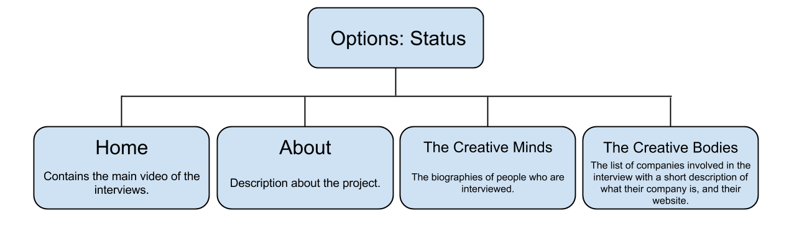

**Components**

**Website**

* Adobe Photoshop CS6
* Adobe Dreamweaver CS6

**Videography**

* Adobe Premiere Pro CS6
* Adobe After Effects CS6
* Canon 600D
* EFS 18 - 135 mm IS
* RODE VideoMic Shotgun Condenser Microphone

**Audience, Beneficiary, and Market Profile**

TargetAudience: Gamers

Age: 17 - 50

Economic group: Upper Class and Middle Class.

Behavioral Determinant/s: Gamer, someone who likes games

Target Beneficiary: Large Video game developing companies.

Target Market: Game Developers

Sample Audience

 Renz Tan is an independent game developer working in an independent game developing company. He has been developing games for 3 years and has 4 years of experience in programming. He graduated under the course of Multimedia Arts but he self-studied programming and has gone through a lot of workshops.

**SCOPE AND LIMITATIONS**

The proponent is planning to interview the developers of Anino games, Secret 6, Synergy88 Studios, and Digital Art Chefs, as well as avid gamers. The proponent will also feature games the proponent wishes to feature including Assassin’s Creed III, Bioshock:Infinite, and Remember Me. The proponent will first ask each individual or team to be interviewed about their free time and shall conduct interview upon their approval.

**REVIEW OF RELATED LITERATURE**

1. Books
   1. Kent, Steve L. *The Ultimate History of Video Games: From Pong to Pokémon and beyond: The Story behind the Craze That Touched Our Lives and Changed the World*. Roseville, CA: Prima Pub., 2001. Print.

The book talks about the history of Video Games pre-Pong. This will show how games were made and what inspired game developers to make the games. It shows the humble beginnings of the ideas of game development: Engineering, Innovation, and Creativity. The Pong game started with the Analogue Pinball game, just made electronically.

The proponent would use this knowledge to show that the ideas for games can come from everywhere.

* 1. Ryan, Jeff. *Super Mario: How Nintendo Conquered America*. New York: Portfolio Penguin, 2012. Print.

In this book, it showed the hardships of the starting-up business of Nintendo when they first stepped on the lands of America. It showed that even one of the best gaming developing company in America started small and had a hard time. The proponent can use this idea to present the idea that the game developers in the Philippines should continue with what they have, since it could be one of the best video games made in the country.

* 1. Melissinos, Chris, and Patrick O'Rourke. *The Art of Video Games: From Pac-Man to Mass Effect. New York: Welcome, 2013*. Print.

This book talks about the different art styles of making games from the beginnings of engineering to the integrated graphics of the games of 2013.

* 1. “The Benefits of Playing Video Games,” Isabela Granic, PhD, Adam Lobel, PhD, and Rutger C.M.E. Engels, PhD, Radboud University Nijmegen; Nijmegen, The Netherlands; *American Psychologist*, 2013. <<http://www.apa.org/pubs/journals/releases/amp-a0034857.pdf>>

This journal contains the positive benefits of video games in regards to the emotion, the social well-being, the cognitive strength, and the motivational views of a gamer. This resource is suitable for the project because the benefits help game developers

B. Digital Resources

a. *Laro: Video Games in the Philippines*. Dir. Sonny Go. Prod. Bernardo Benedicto IV. YouTube. Avoiderdragon, 26 Jan. 2010. Web. 26 Oct. 2013. <<http://www.youtube.com/watch?v=h6gLUFV0ozI>>.

This online video talks about video games in the Philippines, what makes gamers like these video games, the negative side-effects of video games, and what are the threats in video games. This video holds the belief that violent video games aren’t the reasons why gamers are violent. It says that violence is present in most mass media that everyone can acquire. Responsibility and children who play violent video games should be educated are the messages of this video.

Although that’s the message, there are also sub ideas shown. There is also piracy throughout the distribution of the games. It said that some of the first video games released in the PC platform are distributed illegally. This knowledge is important for this project because of it could make developers be creative with how they could distribute their games.

b. “Games made in the Philippines”. Santiago, Juan Carlos. Survey. 13 December 2013.

c. Indie Game: The Movie. Dir. Lisanne Pajot. Dir. James Swirsky. 2012. Film.

This film talks about the life of being an indie game developer. It shows the hardships of being able to design a game, producing it, and distribute it with a limited number of employees mostly consisting of only 2. It also shows the benefits of being an indie game developer, and the fortune it brings if the game has payed off. It’s the ups and downs of an indie game developer.

**PROPOSED METHODOLOGY**

**Pre-production**

PRE-PRODUCTION

1. PREPARE THE FINAL PROJECT GUIDE
2. GATHER RELATED LITERATURE AND WORKS
3. CONDUCT PRIMARY DATA GATHERING - KEY INFORMANT INTERVIEWS

PRODUCTION

1. PREPARE THE WEB PROJECT GUIDE
2. BUILD THE TEXT CONTENT OF THE WEBSITE
3. BUILD THE PROPOSED WEBSITE

POST-PRODUCTION

1. MARKET THE PROJECT
2. RELEASE